Assessment of unique PCB congeners associated with effluent from VPDES or Industrial Storm Water General Permits (ISWGPs) in the Upper Roanoke River watershed
(February 18, 2015)

Background
The Toxics Substances Control Act (TSCA) allows for the inadvertent manufacture of PCBs. The permissible concentration is up to a maximum of 50 parts per million (ppm) provided an annual average of 25 ppm is met by the manufacturer. As PCB data are made available from wastewater monitoring using a sensitive method, it is becoming more evident that PCBs inadvertently produced are ending up in the environment. Prime examples include PCB congeners 11 (Di homolog = 2 chlorines), 206, 207, 208 (collectively Nona homolog = 9 chlorines) and 209 (Deca homolog = 10 chlorines). PCB 11 is associated with a pigment, diarylide yellow, used in the printing industry (Rodenburg, 2010) and PCBs 206, 208 and 209 are associated with the production of paint pigment phthalocyanine green (Hu et al., 2010) and titanium dioxide, a white pigment, both found in paint (Rodenburg, 2012). These PCB congeners are not associated with Aroclors and with the exclusion of PCB 11, can be considered unique tracers.

Upper Roanoke River Watershed
Recently, while performing a statewide analysis for the presence of the five PCB congeners listed above, it was quickly established that the highest levels observed in the state, either from an effluent and/or an ambient presence was within the City of Roanoke - in the upper Roanoke watershed.

Wastewater
Stormwater runoff from Gerdau Roanoke (aka Cycle Systems, VAR050717) was extremely elevated for the homologs identified as Di, Nona, and Deca. Since the highly volatile Di homolog group is short lived in the environment, comparisons between prospective sources only includes the Nona and Deca homolog groups (see Table 1). The PCB data in table 1 have been summed from multiple outfalls and represents the total concentration for the contaminant(s) of interest from that facility. To ensure appropriate comparisons were made, all data (Nona, Deca and tPCB) were treated similarly when summed. PCB loadings for TMDL development are calculated in a similar manner. See attachment 1 for a spatial comparative snapshot of all facilities screened for PCBs in the Roanoke watershed.

Table 1. Gerdau Roanoke compared with other identified sources in the upper Roanoke watershed (note: facilities are placed in order from upstream to downstream).
Permit Number | Facility | PCB Nona (206 -208) ppq | PCB Deca (209) ppq | Uncensored Total PCB ppq
VAR050251 | Federal Mogul Corp., Blacksburg | 452.0 | 41.2 | 39,183.0
VA0001589 | Steel Dynamics | 1,094.0 | 194.0 | 754,995.0
VAR051642 | SEMCO Duct & Acoustical Prod. | 519.8 | 33.6 | 23,743.0
VAR050717 | Gerdau Roanoke (Cycle Systems, Inc) | 42,470.1 | 29,470.6 | 15,399,179.5
Mean PCB Conc. calculated from outfalls with > 1 data point and all outfalls summed to yield PCBs for site.

Ambient Data (water and sediment)

Ambient water and sediment samples were collected in 2008 during the development of the Roanoke River PCB TMDL. Figure 1 includes Roanoke River stations above and below Ore Branch, which is the tributary that receives stromwater from the Gerdau facility. The results, which can be found in Table 2, include total PCBs as well as the Nona PCBs (206 – 208) and Deca PCBs (209).

Figure 1. The red marker is the location of Gerdau; blue markers are Roanoke R. stations.
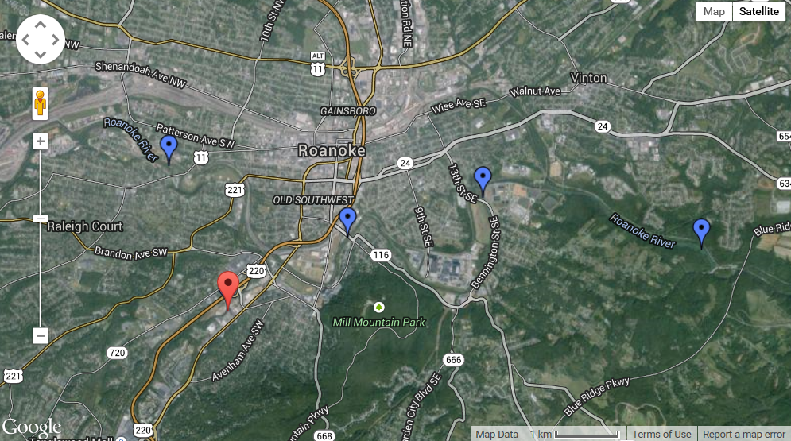
Roanoke RM 207.08
Roanoke RM 199.7
Roanoke RM 202.20
Roanoke RM 204.76
Gerdau
Table 2. PCB results from ambient river water collected during dry weather and storm events and from sediment in the depositional area of the Roanoke River above Niagra Dam.
Ambient Station | Matrix | Weather Condition | PCB - Nona (206-208) ppq | PCB - Deca (209) ppq | Uncensored Total PCB ppq
4AROA207.08 | Water | Dry | 1.2 | 2.7 | 392
4AROA207.08 | Water | Wet | 3.2 | 9.1 | 663
4AROA204.76 | Water | Dry | 3.0 | 6.4 | 1,044
4AROA204.76 | Water | Wet | 14.1 | 19.0 | 3,014
4AROA202.20 | Water | Dry | 4.0 | 4.0 | 1,467
4AROA202.20 | Water | Wet | 18.0 | 18.0 | 3,044
4AROA199.73 | Sediment | NA | 9,941,000 | 21,400,800 | 41,743,000
4AROA199.68 | Sediment | NA | 325,300 | 831,200 | 94,729,000
4AROA199.20 | Sediment | NA | 214,800 | 306,900 | 42,578,000
4AROA199.20 | Water | Dry | 5.0 | 6.0 | 1,305
4AROA199.20 | Water | Wet | 0.0 | 14.0 | 1,588
Note: PCB conc. normalized to part per quadrillion - ppq (sediment conc. normally reported as ppt or ppb).

Discussion

The tPCB concentrations associated with each stormwater outfall from Gerdau are extremely high when compared to DEQ’s Water Quality Criterion (640 ppq). As would be expected at these high levels, the PCBs associated with the outfalls also include all the homolog groups commonly associated with aroclors. However, what sets this apart from the typical PCB dataset is very few wastewaters contain the heavily chlorinated homologs (Nona and Deca) at the elevated concentrations detected from this site. Thus an opportunity is provided to trace these contaminants in the river with a good understanding of their origin.

The data presented above includes all prospective known sources as well as Roanoke River data. The ambient water data is rather inconclusive although these compounds are the most heavily chlorinated and hydrophobic PCBs so it is not surprising the water concentrations are low, particularly during the dry river flow. During wet weather conditions, when the river flow and suspended solids are increased due to stormwater/erosional runoff, these PCBs were slightly elevated. The Nona and Deca PCBs were detected above the Gerdau facility but at reduced concentration when compared to stations below Ore Branch which receives Gerdau’s stormwater. However, the most compelling evidence connecting a prospective source to a sink is associated with the depositional sediments found at ROA199.73, above the Niagra Dam.

While it is always possible there is another active source releasing the Nona and Deca PCBs to the Roanoke River, based on the currently available evidence it does not appear likely. In fact the four permittees listed in Table 1 were the only current sources detected at a >200 ppq screening level. However, given that PCBs 206 – 209 have an association with paint pigments, and perhaps would be associated wastewaters from paint manufacturers, the potential for contaminated stormwater emanating from the abandoned Evans Paint facility cannot be ruled out. Unfortunately the site is located just downstream from ambient station 207.08 and as such there is no evidence to support that contention. Even with consideration of other possible sources, the presence of the Nona and Deca contaminants observed in the stormwater runoff from a metal recycler is rather perplexing, especially at the noted concentrations.

Citations

Hu, Dingfei and Keri C. Hornbuckle, 2010. Inadvertent Polychlorinated Biphenyls in Commercial Paint Pigments, Environ. Sci. Technol., 44, pp. 2822-2827.

Rodenburg, L. A., J. Guo, S. Du, G. J. Cavallo. 2010. Evidence for Unique and Ubiquitous Environmental Sources of 3,3’-Dichlorobiphenyl (PCB 11). Environ. Sci. Technol. 2010. 44, 2816-2821.
Rodenburg, L. A., 2012. Inadvertent PCB production and its impact on water quality [panel discussion presentation. ECOS Annual Meeting, Colorado Springs, CO, 28 Aug 2012.

Attachment 1
(Note: Query based on a 200 ppq screening level for the targeted homologs)

